**ASSIGNMENT**



MAHENDRA INSTITUTE OF TECHNOLOGY

(Autonomous)

NAME: TAMILMANI M

CLASS:4 YEAR ECE

SUBJECT:IBM

TEAM CODE:PNT2022TMID17521

DESIGN PART

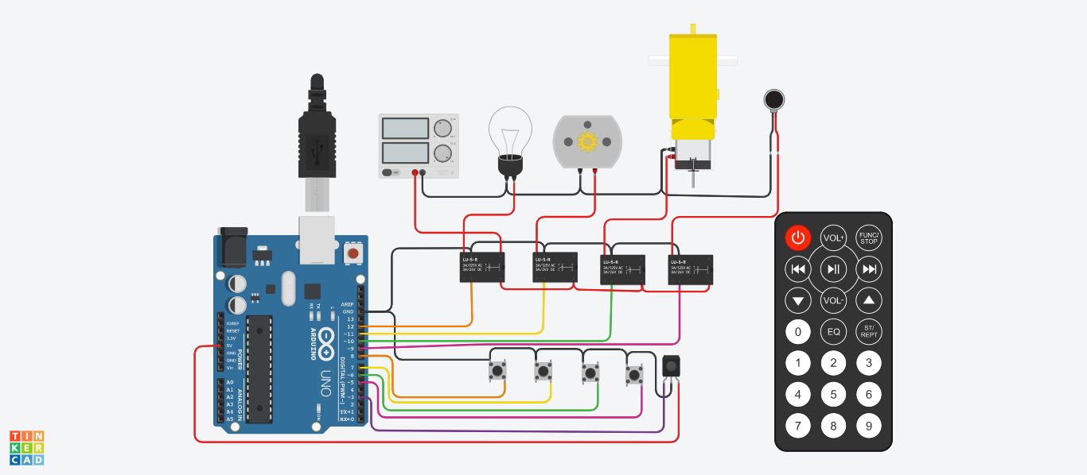

­­­­­­------------------------------------------------------------------------------------------------------------------------------

CODING PART

#include <SPI.h>

#include <Wire.h>

#include <IRremote.h>

const int relay_1 = 12;

const int relay_2 = 11;

const int relay_3 = 10;

const int relay_4 = 9;

const int mswitch_1 = 8;

const int mswitch_2 = 7;

const int mswitch_3 = 6;

const int mswitch_4 = 5;

int RECV_PIN = 3;

IRrecv irrecv(RECV_PIN);

decode_results results;

int toggleState_1 = 0;

int toggleState_2 = 0;

int toggleState_3 = 0;

int toggleState_4 = 0;

void setup() {

Serial.begin(9600);

irrecv.enableIRIn();

pinMode(relay_1, OUTPUT);

pinMode(relay_2, OUTPUT);

pinMode(relay_3, OUTPUT);

pinMode(relay_4, OUTPUT);

pinMode(mswitch_1, INPUT_PULLUP);

pinMode(mswitch_2, INPUT_PULLUP);

pinMode(mswitch_3, INPUT_PULLUP);

pinMode(mswitch_4, INPUT_PULLUP);

}

void relayOnOff(int relay){

switch(relay){

case 1:

if(toggleState_1 == 0){

digitalWrite(relay_1, HIGH); // turn on relay 1

toggleState_1 = 1;

}

else{

digitalWrite(relay_1, LOW); // turn off relay 1

toggleState_1 = 0;

}

delay(100);

break;

case 2:

if(toggleState_2 == 0){

digitalWrite(relay_2, HIGH); // turn on relay 2

toggleState_2 = 1;

}

else{

digitalWrite(relay_2, LOW); // turn off relay 2

toggleState_2 = 0;

}

delay(100);

break;

case 3:

if(toggleState_3 == 0){

digitalWrite(relay_3, HIGH); // turn on relay 3

toggleState_3 = 1;

}else{

digitalWrite(relay_3, LOW); // turn off relay 3

toggleState_3 = 0;

}

delay(100);

break;

case 4:

if(toggleState_4 == 0){

digitalWrite(relay_4, HIGH); // turn on relay 4

toggleState_4 = 1;

}

else{

digitalWrite(relay_4, LOW); // turn off relay 4

toggleState_4 = 0;

}

delay(100);

break;

default : break;

}

}

void loop() {

if (digitalRead(mswitch_1) == LOW){

delay(200);

relayOnOff(1);

}

else if (digitalRead(mswitch_2) == LOW){

delay(200);

relayOnOff(2);

}

else if (digitalRead(mswitch_3) == LOW){

delay(200);

relayOnOff(3);

}

else if (digitalRead(mswitch_4) == LOW){

delay(200);

relayOnOff(4);

}

if (irrecv.decode(&results)) {

switch(results.value){

case 0xFD08F7:

relayOnOff(1);

break;

case 0xFD8877:

relayOnOff(2);

break;

case 0xFD48B7:

relayOnOff(3);

break;

case 0xFD28D7:

relayOnOff(4);

break;

default : break;

}

irrecv.resume();

}

}